Jozuna Examora: Detailed Technical & Security Report
Project Overview
Jozuna Examora is a high-integrity assessment platform. This report provides a deep-dive into the technical implementation of our "Hardened Security" phase, designed to mitigate 99% of common web-based cheating methods.
System Architecture
The following diagram illustrates the lifecycle of a proctored exam session, from permission gathering to automatic violation handling.
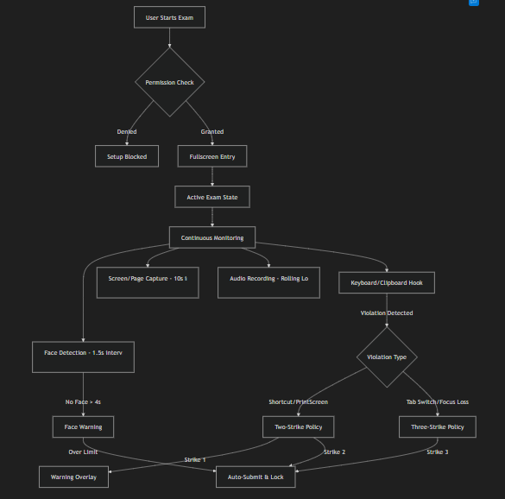
Detailed Security Implementations
1. Advanced Keyboard & Shortcut Hooking
We utilize a global keydown and keyup listener with e.preventDefault() to intercept OS-level and browser-level shortcuts.
- Forbidden Patterns: Ctrl+C, Ctrl+V, Ctrl+X, Ctrl+P, Ctrl+S, F12, PrintScreen.
- Operating System Safeguards: Specifically blocks the Windows "Snipping Tool" (Win+Shift+S) and macOS screenshot triggers.
- Clipboard Sanitization:
typescript
// Periodic background clear every 5 seconds
const interval = setInterval(() => navigator.clipboard.writeText(' '), 5000);
2. Intelligent Face Detection (MediaPipe)
Instead of simple motion detection, we use the MediaPipe BlazeFace machine learning model.
- Thresholds: If no face is detected for 4 consecutive seconds, a security warning is triggered.
- Resource Management: Processing is throttled to 1.5s intervals to ensure battery/CPU efficiency on low-end devices.
3. Screen Sharing Enforcement
The
ScreenRecorder component enforces strict sharing rules via the browser's getSettings() API:
- Constraint: displaySurface === 'monitor'
- Action: If the user attempts to share only a "window" or "tab", the session is immediately blocked, forcing the user to share their Entire Screen.

📱 Cross-Platform Proctoring Strategy
Feature | Desktop Implementation | Mobile Implementation (Safari/Chrome)
Screen Monitoring | Real-time getDisplayMedia stream | html2canvas periodic DOM snapshotting
Audio | Continuous Opus/WebM recording | AAC/MP4 rolling chunks (iOS compatible)
Integrity | Fullscreen API + Focus tracking | Visibility API + Touch-blur effects
Mobile Page Capture (Fallback)
On devices where screen recording is permissions-blocked (iOS/Android), we use html2canvas to capture the current state of the DOM.
- Interval: 10 seconds.
- Optimization: Captures are scaled to 0.5x quality to minimize storage overhead while maintaining readability.

Data Persistence & Resilience
IndexedDB Integration
To bypass the 5MB localStorage limit, all proctoring media is stored in IndexedDB.
- Storage Target: Up to 2GB per session (browser dependent).
- Data Integrity: Audio is saved in "Rolling Chunks". If a user closes the tab mid-exam, all previously recorded chunks are already safely stored in the database.
Key Differentiators
- Zero-Plugin Architecture: No browser extension required.
- Aggressive Blur: The UI becomes 100% unreadable (CSS blur 15px) and interactable the moment the user leaves the tab.
- Managerial Oversight: Every violation is timestamped and categorized (e.g., shortcut_c, print_attempt, tab_switch) for post-exam review.

🛡️ Examora – Exam Security Features Documentation
Overview
Examora implements a multi-layered proctoring system to ensure exam integrity. The security measures are structured across three layers:
- CSS Layer: Prevents text selection, callout menus, and tap highlights
- JavaScript/Event Layer: Blocks keystrokes, clipboard usage, gestures, and context menus
- React Logic Layer: Tracks violations, shows warnings, and auto-submits the exam when required

1. Fullscreen Enforcement
On desktops, the exam enters fullscreen mode when started. If the user exits fullscreen, a 30-second countdown begins, after which the exam is auto-submitted if fullscreen is not restored. During this time, the exam screen is blurred and interactions are disabled.
On mobile devices, fullscreen is not enforced due to browser limitations. Instead, other protections such as overlays and monitoring mechanisms are used.

2. Copy and Paste Blocking
All copy, cut, and paste actions are blocked across both desktop and mobile devices. Keyboard shortcuts like Ctrl+C, Ctrl+V, and Ctrl+X are disabled. Any attempt triggers a violation warning.
On mobile, long-press menus and text selection are also disabled using CSS and event blocking.

3. Screenshot Blocking
On desktop:
- Print Screen and screenshot shortcuts are blocked
- Clipboard is cleared immediately after detection
On mobile:
- A black overlay appears during screenshot attempts
- Multi-touch gestures used for screenshots are blocked
However, OS-level tools cannot be fully controlled.

4. Keyboard Shortcut Blocking
All major shortcuts are disabled, including:
- Copy, paste, cut
- Print, save, view source
- Developer tools (F12, Ctrl+Shift+I, etc.)
- Screenshot shortcuts
Each violation is tracked and contributes to the strike system.

5. Right-Click Blocking
Right-click and context menus are completely disabled. The browser menu does not appear, ensuring users cannot inspect or copy content.

6. Tab Switching Detection
When a user switches tabs or minimizes the browser:
- A warning is issued for the first two violations
- On the third violation, the exam is automatically submitted

7. Mouse and Focus Tracking
If the cursor leaves the exam window or the browser loses focus:
- A 30-second timer starts
- If the user does not return, the exam is auto-submitted

8. Face Detection Monitoring
The system continuously monitors the user's face using the camera:
- If no face is detected for more than 4 seconds, a warning is triggered
- After 3 warnings, the exam is auto-submitted

9. Clipboard Clearing
The clipboard is automatically cleared every 5 seconds to prevent misuse. It is also cleared during events like blur, focus, or screenshot attempts.

10. Print Blocking
Printing is completely restricted. Any attempt to print triggers a violation and prevents the action.

11. Violation Strike System
- 1st violation: Warning message
- 2nd violation: Immediate exam auto-submission
Tracked violations include:
- Copy/paste attempts
- Screenshot attempts
- Restricted keyboard shortcuts
Some actions like right-click or tab switching are tracked separately.

12. Focus and Blur Handling
When the window loses focus:
- The exam screen is blurred
- Interaction is disabled
- A timer starts for auto-submission
Focus restoration removes the blur and cancels the timer.

13. Mobile-Specific Protections
Additional protections on mobile include:
- Blocking long-press menus
- Preventing multi-touch gestures
- Disabling text selection
- Removing tap highlights
- Showing a black overlay during screenshots

Security Limitations
Some limitations cannot be fully controlled:
- OS-level screenshots and screen recording
- iOS screenshot detection
- Rooted or jailbroken devices
- Clipboard permission restrictions on mobile

